Problem 1:

a)

$$β= \frac{ m}{A*C_{D}}=71.56 kg/m^{2}$$

b)

$$C= \frac{{ ρ}_{0*H}}{2* β*sin⁡(γ)}=-12.73$$

c)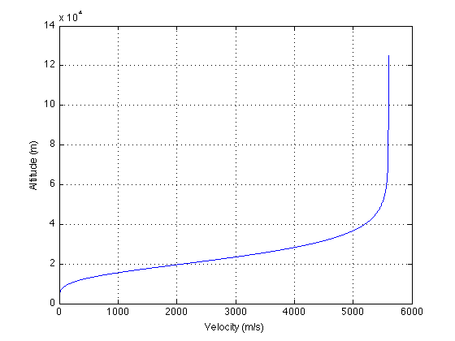

d)

$$Max Deceleration alititude=25290 meters$$

$$Max Deceleration=16.94 g's$$

e)

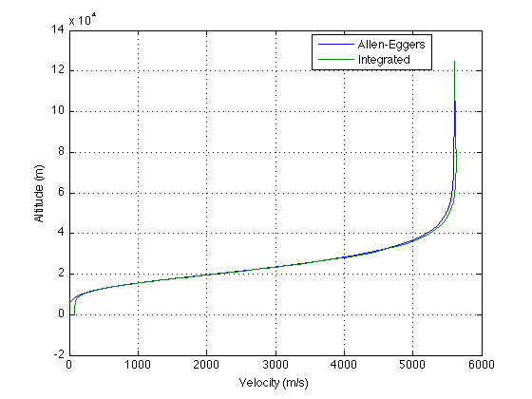

This just shows how close the Allen-Eggers solution is to a “higher quality” solution of integrating over time.

f) 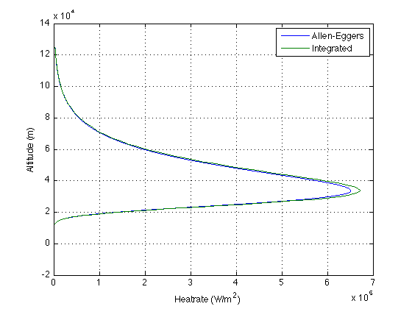

g)

$$Peak Analytic \dot{q}=651380 \frac{W}{m^{2}}$$

$$Peak Allen \dot{q}=651380 \frac{W}{m^{2}}$$

$$Peak integrated \dot{q}=671382 \frac{W}{m^{2}}$$

$$J_{S }analytic=20978231 \frac{J}{m^{2}}$$

$$J_{S }integrated=20899179 \frac{J}{m^{2}}$$

The analytic peak rate is very close to what is expected from the graph, as seen in the first two answers.

h)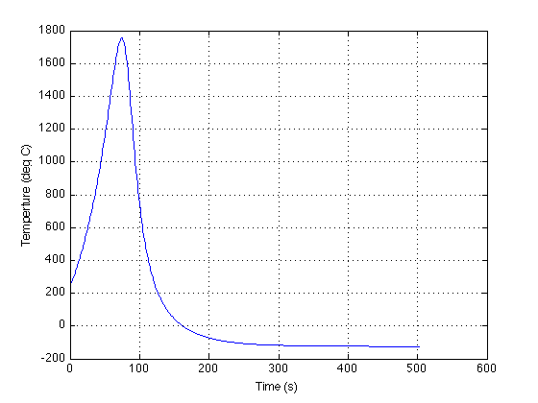

i)

$$mass fraction=4.69\% \\ TPS mass=28.295 kg$$

$$TPS structure=TPS mass*15\%= 4.244 kg$$

$$TPS total mass=32.540 kg$$

j)

$$Peak Allen \dot{q}=65.13 \frac{W}{{cm}^{2}}$$

$$Peak integrated \dot{q}=67.13 \frac{W}{{cm}^{2}}$$

$$J_{S }analytic=2097.82 \frac{J}{{cm}^{2}}$$

$$J_{S }integrated=2089.92 \frac{J}{{cm}^{2}}$$

The values are within a reasonable value from 56 $\frac{W}{{cm}^{2}}$ and 2339 $\frac{J}{{cm}^{2}}$

Extra Credit: I attempted this, but was unable to get the boundary conditions working. I have shown my work in the Matlab script.

Problem 2:

a)

$$diameter=13.30 m$$

b)

$$difference \%=13.68 \%$$

Problem 3:

a)

$$S_{0 }=4.432 cm$$

b)

$$S_{f }=6.715 cm$$

c)

$$Area of a leg=7710.74 {cm}^{2}$$

$$Radius of a leg=156.665 {cm}^{2}$$

d)

